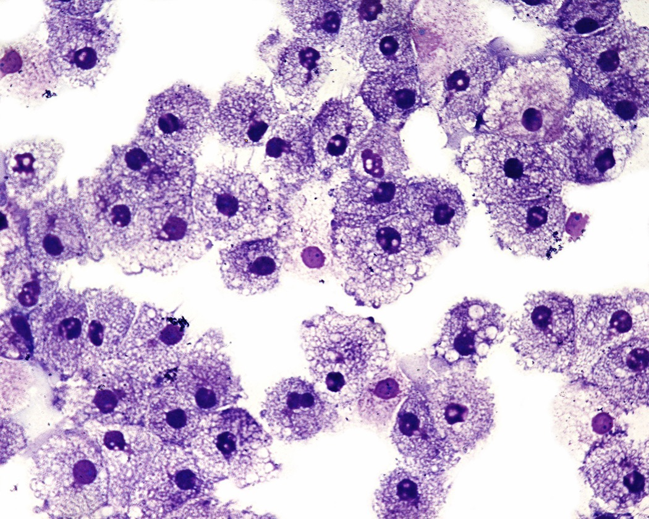 Tas Valley Cell Church 2017

GROWING IN DISCIPLESHIP

- Following Jesus.
- Learning to see Him more clearly, love Him more dearly and follow Him more nearly.

What are the good things we are doing already?

- Leading role in running Benefice Alpha courses and youth alpha.
- Nurturing new believers through cell church groups inc youth cells which have grown considerably.
- Leading Role in Prayer 24-7.
- Interesting study material – e.g. Faith Hope, Love and Everything in between
- Youth cells have been restricted and is peer led, with observance by adult.
- Special Me Group now up and running
- New cells (including parent and toddler group) started

How do we feel God is calling us to grow in this area in the long term?

- Grow in prayer and personal discipleship
- Grow in personal financial giving.
- Continue to develop cell church leadership including youth leadership so it can continue to grow

What steps shall we take this year?

- Encourage giving through Gift Aid, regular standing orders and text giving
- Take lead in Prayer 24-7 (May/June)
- Encourage more involvement in the Cell Church leadership, e.g. become a trustee
- Prioritized training meetings

GROWING IN SERVICE

- Responding to human need
- Caring for God’s creation
- Transforming unjust structures in society

What are the good things we are doing already?

- “Secret pastor” initiative – encouraging care and prayer for others
- Initiatives of individuals and cells eg. “Labours of Love” Gardening etc, litter pick
- Youth cells have particularly helped with Holiday Club (Christian Aid) and Posada Festival (Toybox)
- Supporting rural evangelism project
- Special Me Initiative for people with special needs is up and running
- Monthly meals for the over 65s established
- Monthly film night for the whole community in the Winter months established
- Prayer 24-7 experience is helping our church schools set up prayer space.

How do we feel God is calling us to grow in this area in the long term?

- Parent and toddler support
- A men’s group which might be focused on practical acts of service like “labours of love”

What steps shall we take this year?

- Looking to establish a Men’s Group which might be focused on practical acts of service like “Labours of Love”

GROWING IN NUMBERS

- Helping more people to find faith
- Helping people to join our congregation

What are the good things we are doing already?
- Youth and adult Cells run regular impromptu outreach/social events.
- Begun 7 years ago, the Cell church has grown to about 60 adult and 25 youth members
- Cells are the mainstay of the benefice alpha courses
- Recent 14-18s Alpha very successful.

How do we feel God is calling us to grow in this area in the long term?
- More men!
- Help each other in cell to encourage each other in Evangelism and to help each other to do it.
- Continue to have cell-run alpha courses and support Prayer 24-7
- More lay leadership with Bishop’s Mission Order with future of its ministry on a firm footing – recognition as a church and continuity of leadership
- Find more ways to engage with people who are not yet ready to go on Alpha.

What steps shall we take this year?
- Making Mission Possible Training in Jan & Cell Series on Evangelism/ Sharing Good News in Feb
- JAM is preparing to receive new young people after Easter.
- Two Alpha Courses running this year.
- A small team from the cell church is focusing on how we can help more men to find faith and do church in a way which is meaningful

